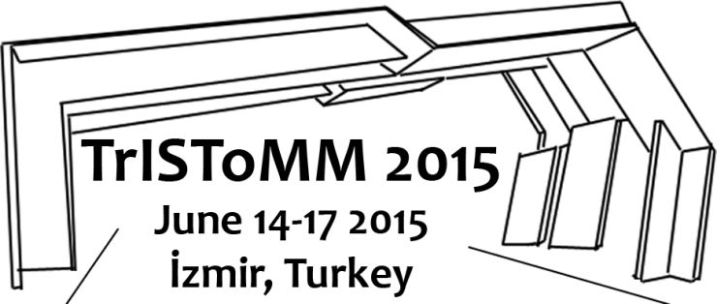
TRC IFTOMM SYMPOSIUM ON THEORY OF MACHINES AND MECHANISMS
REGISTRATION FORM
Participant name
Paper title(s)
Dates of arrival/departure
Time of flight arrival/departure
Do you want to stay in the IZTECH guesthouse  http://www.iyteyasammerkezi.com/ | ( ) Single room: 55 Turkish Lira/day (∼20 Euro/day)  ( ) Twin room: 2 x 50 Turkish Lira/day (∼18 Euro/day)  ( ) Triple room: 3 x 45 Turkish Lira/day (∼15 Euro/day)  ( ) Quad room: 4 x 40 Turkish Lira/day (∼14 Euro/day)
Mechanism and Drive Syntesis Lecture on June 14 | ( ) I will participate ( ) I will not participate
Boat tour on June 17 | ( ) I will participate ( ) I will not participate
Accompanying person name(s) (if any)
Symposium activities (mark relevant ones) for the accompanying person. Registration of accompanying people is must to attend the activities. Add extra rows to the table for multiple accompanying people. | The accompanying person will attend  ( ) the presentations and lunches  ( ) the welcome cocktail ( ) the gala dinner  ( ) Kemeraltı tour on June 15  ( ) Alaçatı-Çeşme tour on June 16  ( ) the boat tour on June 17
The registration form should be sent to umts@iyte.edu.tr together with a copy of the registration fee receipt. Registration fee and account information: http://umts.iyte.edu.tr/en/kayit/

If time of arrival/departure for flights are not set yet, please send an e-mail to umts@iyte.edu.tr when the flight details are set. The time-table for the bus travel between İzmir Airport and IzTech will be arranged accordingly.
The number of rooms in the guest house is limited, so reservations will be made according to the order of requests. Guest house fees will be paid during check-in. TV, AC, wi-fi, hot water, towels, slippers and shampoo will be available in the rooms.

